**W6** PRACTICE

*My SQL*

## *At the end of his practice, you should be able to…*

* Establish a **MySQL connection** on the back-end app
* Implement a **repository** layer using **MySQL queries**
* **Test the endpoints** (REST API client + front-end app)
* **Extends the project** to handle **4 tables** in the database

## *How to start?*

* Download **start code** from related MS Team assignment
* Run npm install on both front and back projects
* Run npm run dev on both front and back projects to run the client and the server

## *How to submit?*

* Submit your **code** on MS Team assignment

## *Are you lost?*

*To review MySQL queries syntax*

<https://www.w3schools.com/mysql/mysql_sql.asp>

*To install My SQL Server (if needed)*

<https://dev.mysql.com/doc/refman/8.4/en/windows-installation.html>

<https://dev.mysql.com/downloads/>

*To connect Node back end to MySQL*

<https://www.w3schools.com/nodejs/nodejs_mysql.asp>

<https://sidorares.github.io/node-mysql2/docs/documentation>

# EXERCISE 1 – MySQL **Manipulation**

**Before starting !**

You should have a MySQL Server running. Check it out with bellow command:

mysql -u root -p

You should see MySQL monitor run properly:

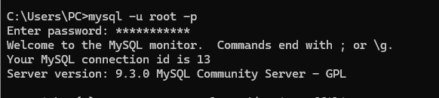

If not, you need to install and configure MySQL server properly.

<https://dev.mysql.com/doc/refman/8.4/en/windows-installation.html>

**Q1 -** **Create the database and the table of articles**

* Open the terminal and launch MySQL monitor:

mysql -u root -p

* Create a new database (e.g. **week6Db**) using the command line
* Create a new table (articles) with the columns below:

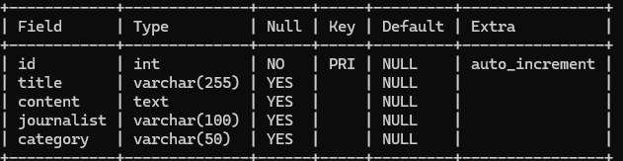

**Q2 -** **Review My SQL queries**

* Complete the bellow table with the appropriate MySQL query

|  |  |
| --- | --- |
| Use case | My SQL Query |
| Get all articles | SELECT * FROM articles |
| Get articles written by the journalist ‘RONAN” | Select * from articles where journalist = ‘RONAN’; |
| Add an article | INSERT INTO articles (title, journalist, content) VALUES ('New Article', 'RONAN', 'Article content'); |
| Delete all articles whose title starts with “R” | DELETE FROM articles WHERE title LIKE 'R%'; |

# EXERCISE 2 – MySQL on **Backend**

*For this exercise, you start with a start frontend and a backend code.*

**The goal for this exercise is to replace the provided mock repository with a MySQL repository.**

**Q1 - Run Frontend & Backend**

Open a dedicated terminal to run the server:

cd back

npm i

npm run dev

Open a dedicated terminal to run the client:

cd front

npm i

npm run dev

Open the browser and check the front end is correctly **connected with the back end** :

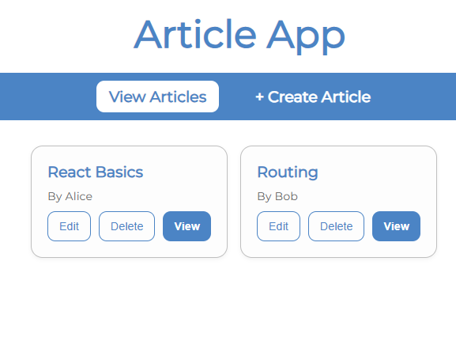

The project already works as we provide fake data (mock repository).

*Let’s understand in detail the back and front ends.*

***FRONT-END***

**Q2 - Look at ArticleForm**

How does the component know whether to create a new article or update an existing one?

The articlesfrom components determines wheter to create a new articles or update the existing one by using the isEdit prop and the id from useParams. If isedit is true and an id is exist, the useEffect will hook fetch the articles data with getArticlesById.

Why is the **useParams** **hook** used in this component? What value does it provide when isEdit is true?

The useParams hook is used in the ArticleForm component to extract the id parameter from the URL, which identifies the article to be edited. When isEdit is true, the id provided by useParams is used in the useEffect hook to fetch the article’s data with getArticleById(id), populating the form with the article’s details. It is also used in handleSubmit to update the article with updateArticle(id, formData)

Explain what happens inside the **useEffect** hook. When does it run, and what is its purpose?

Inside the useEffect hook, if isEdit is true and an id exists from useParams, the fetchArticle(id) function is called. This function sets isLoading to true, fetches the article’s data using getArticleById(id), updates the formData state with the article’s details, and handles errors. The hook runs once when the component mounts, due to the empty dependency array ([]). Its purpose is to populate the form with the existing article’s data when the component is in edit mode, allowing the user to edit the article.

**Q3 - Look at the ArticleList**

How are the three promise states (loading, success, and error) handled in the fetchArticles function?

The three promise states handled in the fetchArticles function by using usestate. If the articles is true it display Loading in the success state. Then it use try and catch operation to handle the getarticles.

What is the role of the ArticleCard component, how does it communicate with the parent ArticleList?

The role of articlescard component is to handle the button operation of articles card and it’s rendering the single articles to allow user interact with articles. It communicates with the parent articleslist by receive the object and call back the function.

***BACK-END***

**Q4 - Why 3 layers ?**

The backend is composed of the below 3 layers : routes, controllers and repository :

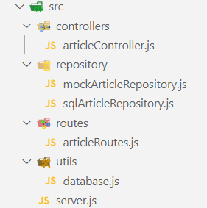

Describe the **responsibility** of each **layer** by completing the table below:

|  |  |
| --- | --- |
| LAYTER | RESPONSABILITIES |
| Routes | Handle the url pattern that determine which components is renders or action. |
| Controller | Controller use to handle how the function in the router is perform. |
| Repository | Use to define the database structure and manage data access logic. |

**Q5 -**  **Implement the database connection**

Here are the files you need to update to **connect the backend to the database**:

|  |  |
| --- | --- |
| FILE | RESPONSABILITIES |
| /.env | securely store your MySQL database credentials |
|  |  |
| /utils/ database.js | Holds the **MySQL connection setup** logic  *Responsible for creating and exporting a* ***connection******pool*** *that other parts of the application can use.* |
| /repository/sqlArticleRepository.js | Provides **a clean, reusable interface** to interact with the articles table in your **MySQL database**.  *Encapsulates all the SQL queries related to articles and exposes them as functions that the rest of your application can call.* |

Here is what you need to do:

* **.env file**

Create a .env file to securely store your MySQL database credentials.

*See* [*https://www.npmjs.com/package/dotenv*](https://www.npmjs.com/package/dotenv)

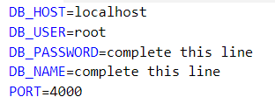

* **utils/database.js** 
  + Create a **MySQL connection pool** using the credentials from the .env file.

<https://sidorares.github.io/node-mysql2/docs#using-connection-pools>

* + Export this connection pool so it can be used by other modules in the project.
* **repositories/sqlArticleRepository.js**

Implement the following functions to interact with the articles table in the database:

getAll() — fetch all articles

getById(id) — fetch one article by ID

create(article) — insert a new article

update(id, article) — update an existing article

remove(id) — delete an article by ID

Use the connection pool from database.js to **execute the SQL queries** inside these functions.

*As an example, to implement getAll() :*

export async function getArticles() {

  const [rows] = await pool.query("SELECT * FROM articles");

  return rows;

}

**Q6 -**  **Test the endpoints**

To test the implementation of MySQL repository (*create, update, remove, get articles…)*

* First, perform tests using a **REST API client** (thunder or postman)
* Then, run the **front-end project** and asset the views work properly

# EXERCISE 3 – Handle **Journalists**

*For this exercise, you continue on the previous exercise code.*

Now, users want to see **who wrote each article** to better understand the source.

* You will need to update the app, so the article page shows the **journalist’s name and info.**
* You will need to provide a journalist view, showing all articles written by a specific journalist.

**Database**

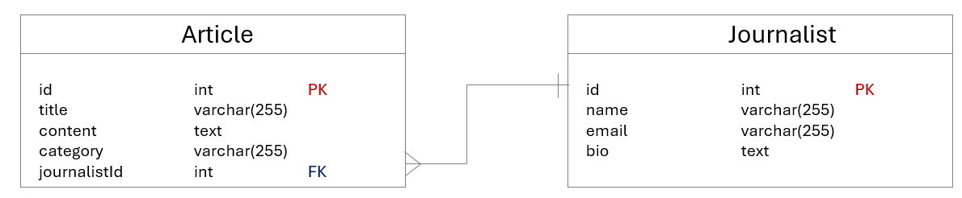

*Update your database structure to handle the journalist table*

* Create **journalists table** with fields: id, name, email, bi
* Update **articles table** to include journalist_id foreign key
* **Populate the database** with some fake data

**Back End**

* Implement **repository** methods:x
  + Fetch articles with joined journalist name (using **SQL JOIN**)
  + Fetch all articles written by a specific journalist name (using **SQL JOIN**)
* Add **controller** functions:
  + Get all articles by journalist ID
* Define **new API routes**:
  + GET /api/articles/:id article + journalist name.
  + GET /api/journalists/:id/articles articles list by journalist.

**Front End**

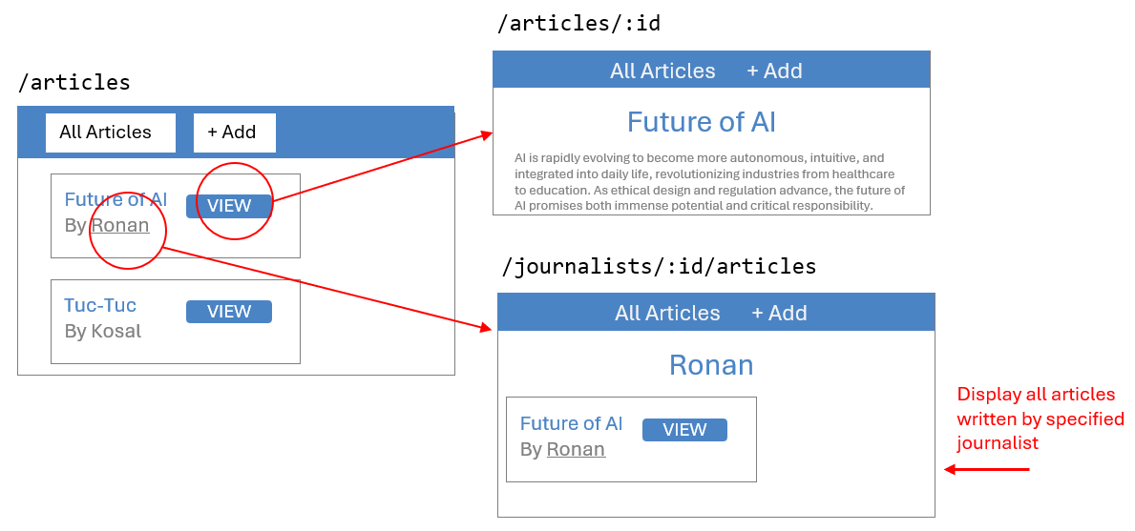

*An additional view shall display all articles written by the specific journalist*

* Update **Article Details page**:
  + Display journalist name alongside the article.
* Create **Journalist Articles List page**:
  + Display all articles by selected journalist.
* Add navigation:
  + From Article Details page, allow users to click journalist name to view **that journalist’s articles.**
* Update API calls:
  + Fetch combined article + journalist data.
  + Fetch articles filtered by journalist ID.

# EXERCISE 4 – Handle **Tags BONUS**

*For this exercise, you continue on the previous exercise code.*

Now, users want to easily **assign tags to articles**.

The users can then filter articles by selecting different tags.

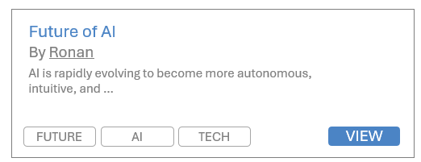

You will need to add categories to articles and let users filter the article list by selecting a category.

Database

* Create a new **table** Category (id, name).
  + *What kind of relationships do we have between articles and categories?*

**Back End:**

* Implement repository methods to:
  + Retrieve all categories.
  + Retrieve all articles filtered by category, using JOIN to include category name.
* Add a new API endpoint to get articles by category ID.

**Front End:**

* Add a **multiple categories filter UI component** on the **article list page** (multiple choice dropdown, chipset selector).
* When categories are selected, fetch and display only articles in those categories.
* Display categories names alongside articles in the list.